<https://www.tektutorialshub.com/angular/angular-location-strategies/>

<https://elelad.medium.com/avoid-cache-trap-when-serving-angular-app-c5981653d156>

Package.json vs Package-lock.json

Dependencies vs DevDependencies vs PeerDependencies

dependencies: enlists the required libraries

devDependencies: enlists the libraries that are used only for development purposes i.e., libraries for unit testing command: npm install <package name> --save-dev

library versions, ^, ~

library version format <major>.<minor>.<revision>

major: increments for comprehensive upgrade

minor: increments for new functionality

revision: increments for bug fixes

^: will accept minor and revision versions

~: will accept revisions

ng-template vs ng-container vs ng-content

ng-template: used to group some html content but does not get displayed on its own, used in conjunction with some structural directives i.e., *ngIf, *ngFor, [ngSwitch]

ng-container: it provides grouping of html elements without adding additional html element like div, span. Internally it adds one element to DOM that is of type Comment.

ng-content: used to project some html content into child component, place html content in between the child component’s selector and inside child component template use <ng-content select=’’></ng-content>. In case of multiple ng-template of same type, last one will get added to dom

@ViewChild

ViewChild used to refer element in DOM, type depends on the element type

html element: ElementRef

ng-template : TemplateRef

ng-container: ElementRef

ng-content : Undefined

component : <Component Type>

ElementRef TemplateRef ViewContainerRef

ElementRef: wrapper around the actual html element

TemplateRef:

ViewContainerRef: Injected VCR, Container will be the Host element(Parent to the component), hence createEmbeddedView or createComponent will insert node into the container Element and created view will become sibling to the component where it’s been used.

ComponentFactoryResolver

EntryComponent

The entryComponents array is used to define only components that are not found in html and created dynamically with ComponentFactoryResolver. Angular needs this hint to find them and compile. All other components should just be listed in the declarations array. With Angular9+ no need of this entry IVY Compiler

*ngTemplateOutlet

It can be used to insert a template that are not generated by a loop or subject to a condition. Additionally, we can attach a context object to the [target](https://angular.io/api/core/EmbeddedViewRef) template ref by setting [ngTemplateOutletContext]. Context should be an object; the object's keys will be available for binding by the local template let declarations. $implicit is used to pass values to all default property



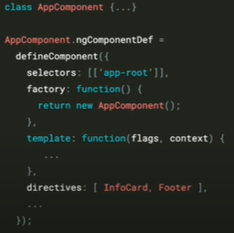

At compile time angular stores all the scoped directives(components) to the directive property of component definition object, during element creation matches every tag to it, if found calls the factory function of that directive. Factory function resolves dependency and instantiate. To avoid this directive matching each time, angular maintain a data array TView (template view) 1 per directive type. TNode {tag name, pointer to dependent directive def}

LView

LView is a data array to store each element created by angular, this facilitates faster access to created elements by change detector. Each component has its own LView.

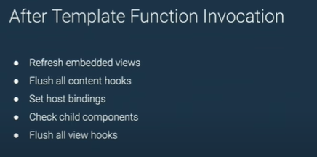

Zone.js and NZone

Zone.js is used to track the synchronous/asynchronous tasks via Monkey patching approach; NZone is just the wrapper around Zone.js. NZone provides option to run codes outside/inside Angular’s change detection.

Change detection occurs when application state changes

1. Event Callback
2. Network Call (XHR)
3. Timers (setTimeout, setInterval)



href vs routerLink

href will cause whole page to get downloaded (against the SPA)